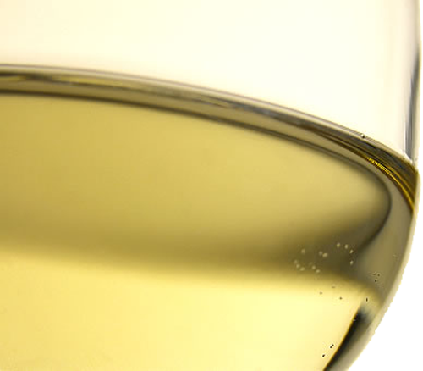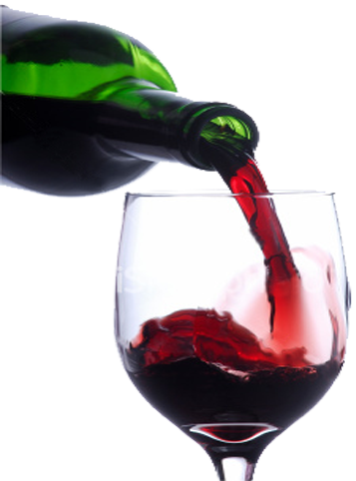

**BAN FRANSISCO BRONICLE**

**WINE LABEL TEMPLATE**

***2025***

**PUBLIC TASTING**

**FORT MASON – SAN FRANSISCO**

**NOVEMBER 15 – 2 TO 5 PM**

**Presented by:**

**LARGEST COMPETITION OF AMERICAN WINES IN THE WORLD**

**FOR INFORMATION AND TICKETS, VISIT www.example.com**

**Wine Label**